

**User Manual**

Charity Second-hand Online Store

**Revised records**

|  |  |  |  |
| --- | --- | --- | --- |
| **Update Date** | **Version** | **Description** | **Name** |
| 24th May 2020 | V1.0 | Initial user manual |  |
|  |  |  |  |
|  |  |  |  |

Table of Contents

1 Introduction 3

2 Function Introduction 4

2.1 Main page 4

2.2 Contact Us 6

2.3 About Us 6

2.4 Registration 7

2.5 Login 9

2.6 Logout 9

2.7 Password Recover 10

2.8 Personal Information 11

2.9 Auction 12

2.10 Make Appointments 13

2.11 Goods Management 15

2.12 Shopping Cart 17

2.13 User Management 18

2.14 Order Management 19

# Introduction

The purpose of the user manual is to introduce the usage of the product to the client. In order to enhance the user's understanding of the product and master the basic operation process. Although the project team will give a training before delivering to the client. However, users of the product are constantly changing, so it is necessary to prepare this user manual. If the users are not familiar with the operation of any function or have any questions in the future, users can find the answers in this user manual. If the users of the product changes or increases, the user manual can also be used as the material for later training. To assist and guide new users on how to use the product. The user manual uses simple text descriptions and pictures of related functions to help users understand how to use the product more easily. Therefore, users can quickly competent to operate the system.

# Function Introduction

## Main page

2.1.1 Description

The function of the main page includes goods information, goods categories, search box and other details.

2.1.2 Role

Administrator, User.

2.1.3 Function screenshots



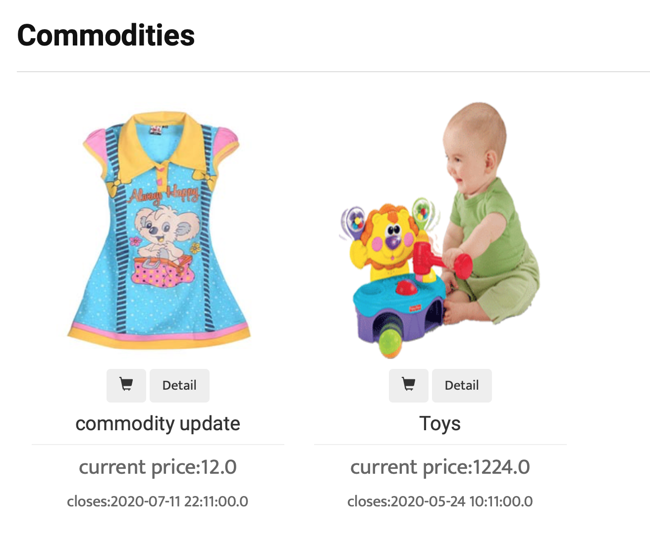

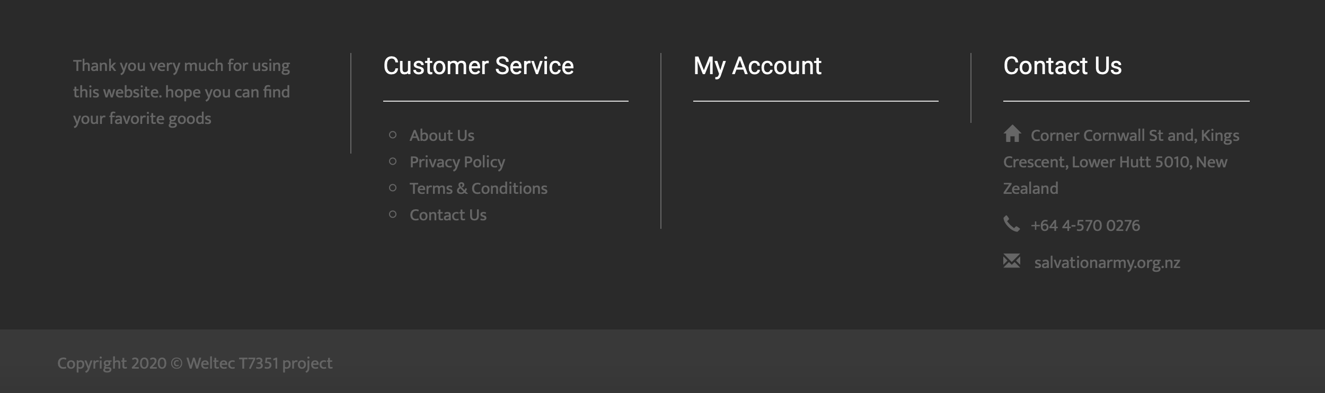



2.1.4 Operation instruction

User can open the main page by using any browsers. On this page, user can login or logout his/her account, view the advertisement banner and some goods which are going to close, view different goods categories and search goods by the searching box.

## Contact Us

2.2.1 Description

The function is to introduce the website. It should include map and text.

2.2.2 Role

Administrator, User.

2.2.3 Function screenshots

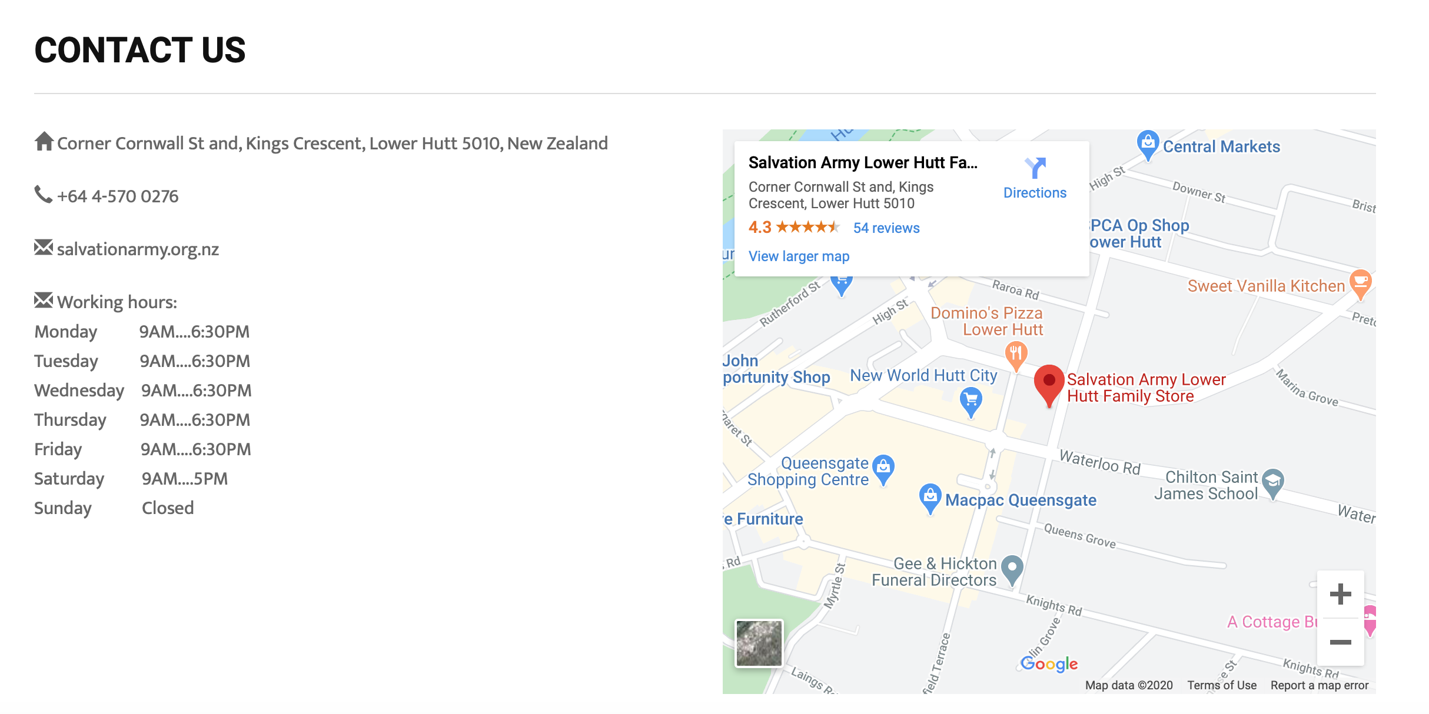

2.2.4 Operation instruction

User can view the function on the main page and know the detailed address of the second-hand store and view the map by this function.

## About Us

2.3.1 Description

The function is to introduce the website. It includes picture and text so that user can understand the mission of the website.

2.3.2 Role

Administrator, User.

2.3.3 Function screenshots

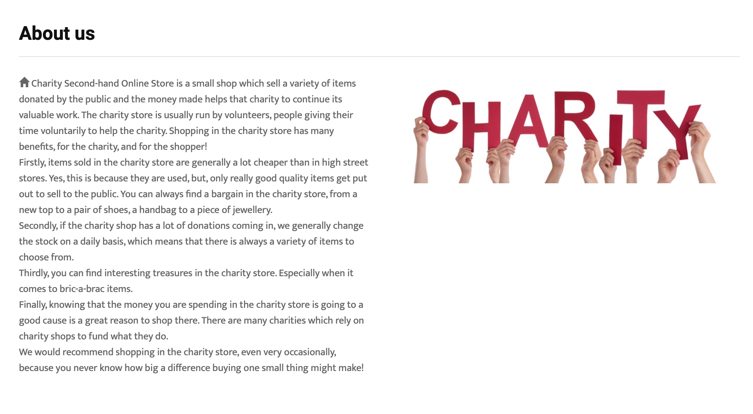

2.3.4 Operation instruction

User can view the function on the main page.

## Registration

2.4.1 Description

The function of the registration is to create a new account for user.

2.4.2 Role

Administrator, User.

2.4.3 Function screenshots

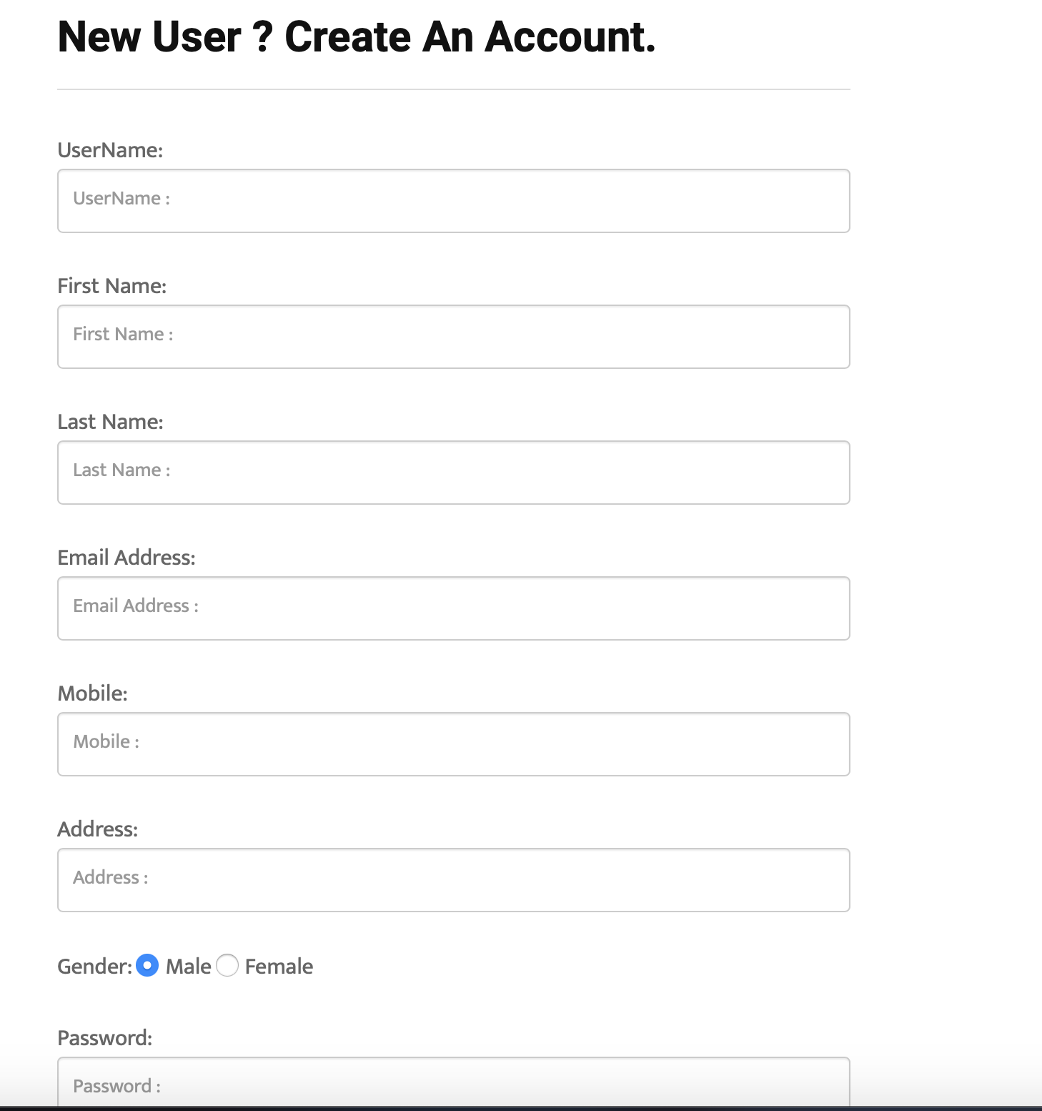

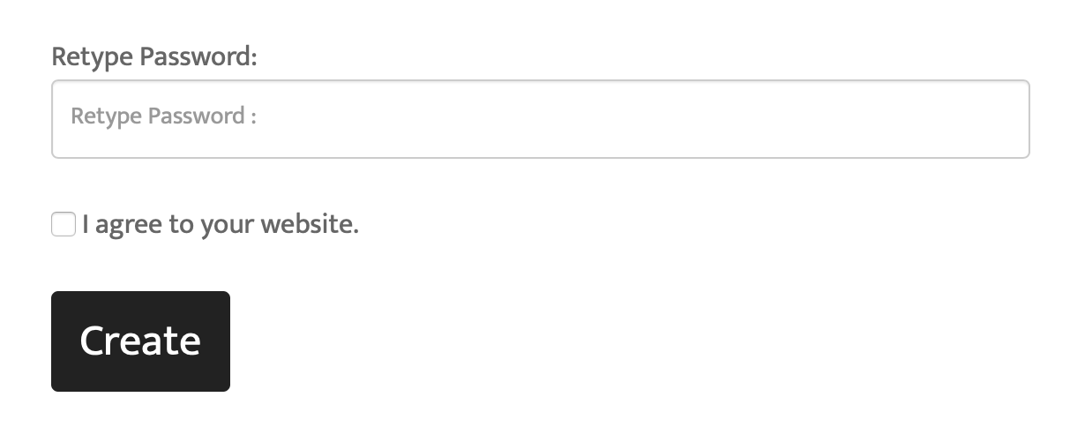

2.4.4 Operation instruction

User can register a new account on this page. User should input username, first name, last name, Email, password, gender, mobile and address.

## Login

2.5.1 Description

The function of the login is to login the website by using an existing account.

2.5.2 Role

Administrator, User.

2.5.3 Function screenshots

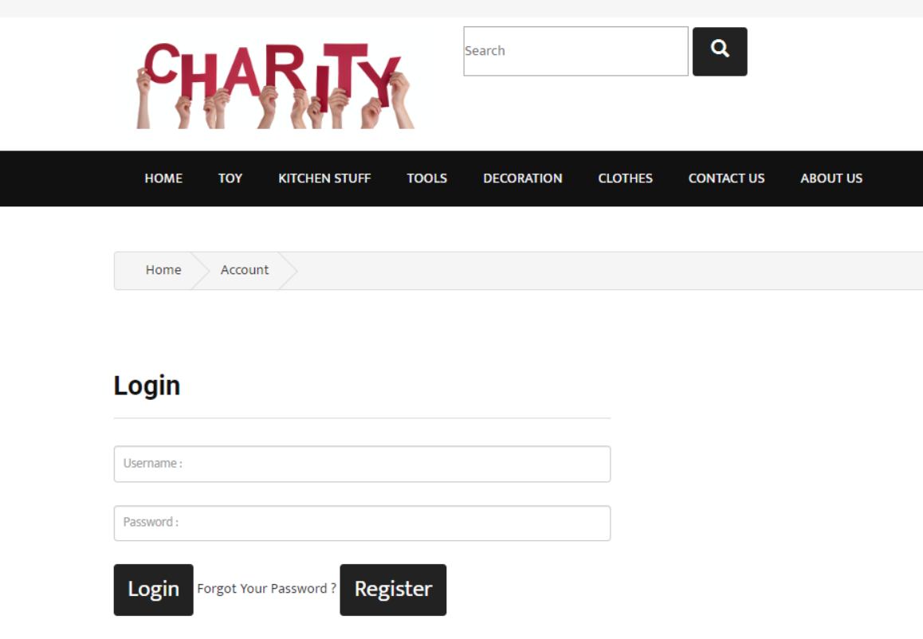



2.5.4 Operation instruction

User can login the system by inputting right username and password, and click login button. After user login the system, user can see his/her name on the area of the main page as above.

## Logout

2.6.1 Description

The function of the logout is to logout the website when a user is login.

2.6.2 Role

Administrator, User.

2.6.3 Function screenshots



2.6.4 Operation instruction

User can logout the system by clicking logout button. After user logout the system, user can login it again.

## Password Recover

2.7.1 Description

The function is to change a new password when a user forgot his/her password. It will verify user’s mobile number and email information.

2.7.2 Role

Administrator, User.

2.7.3 Function screenshots

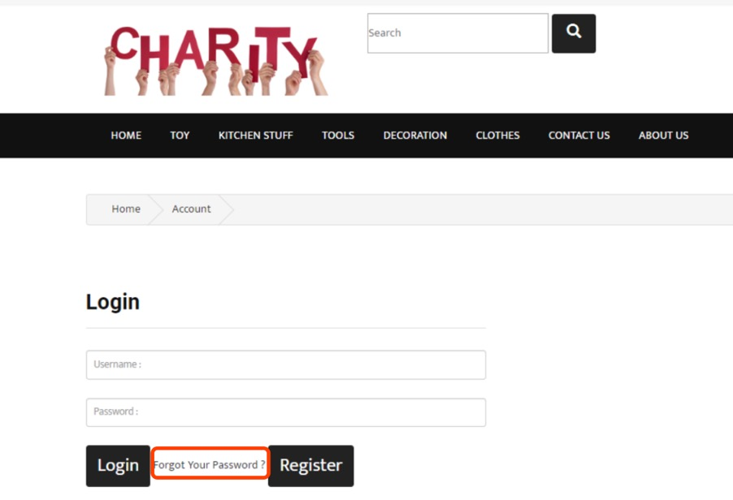

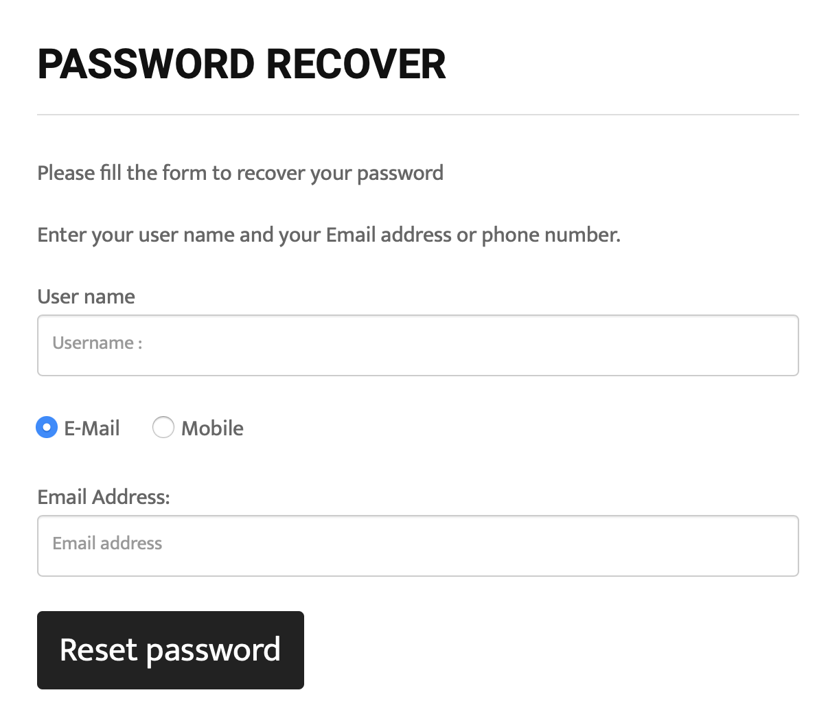

2.7.4 Operation instruction

User can reset password by inputting right username and Email, and click reset password button as above.

## Personal Information

2.8.1 Description

The function of the personal information can display the details of personal information and support users to modify them.

2.8.2 Role

Administrator, User.

2.8.3 Function screenshots

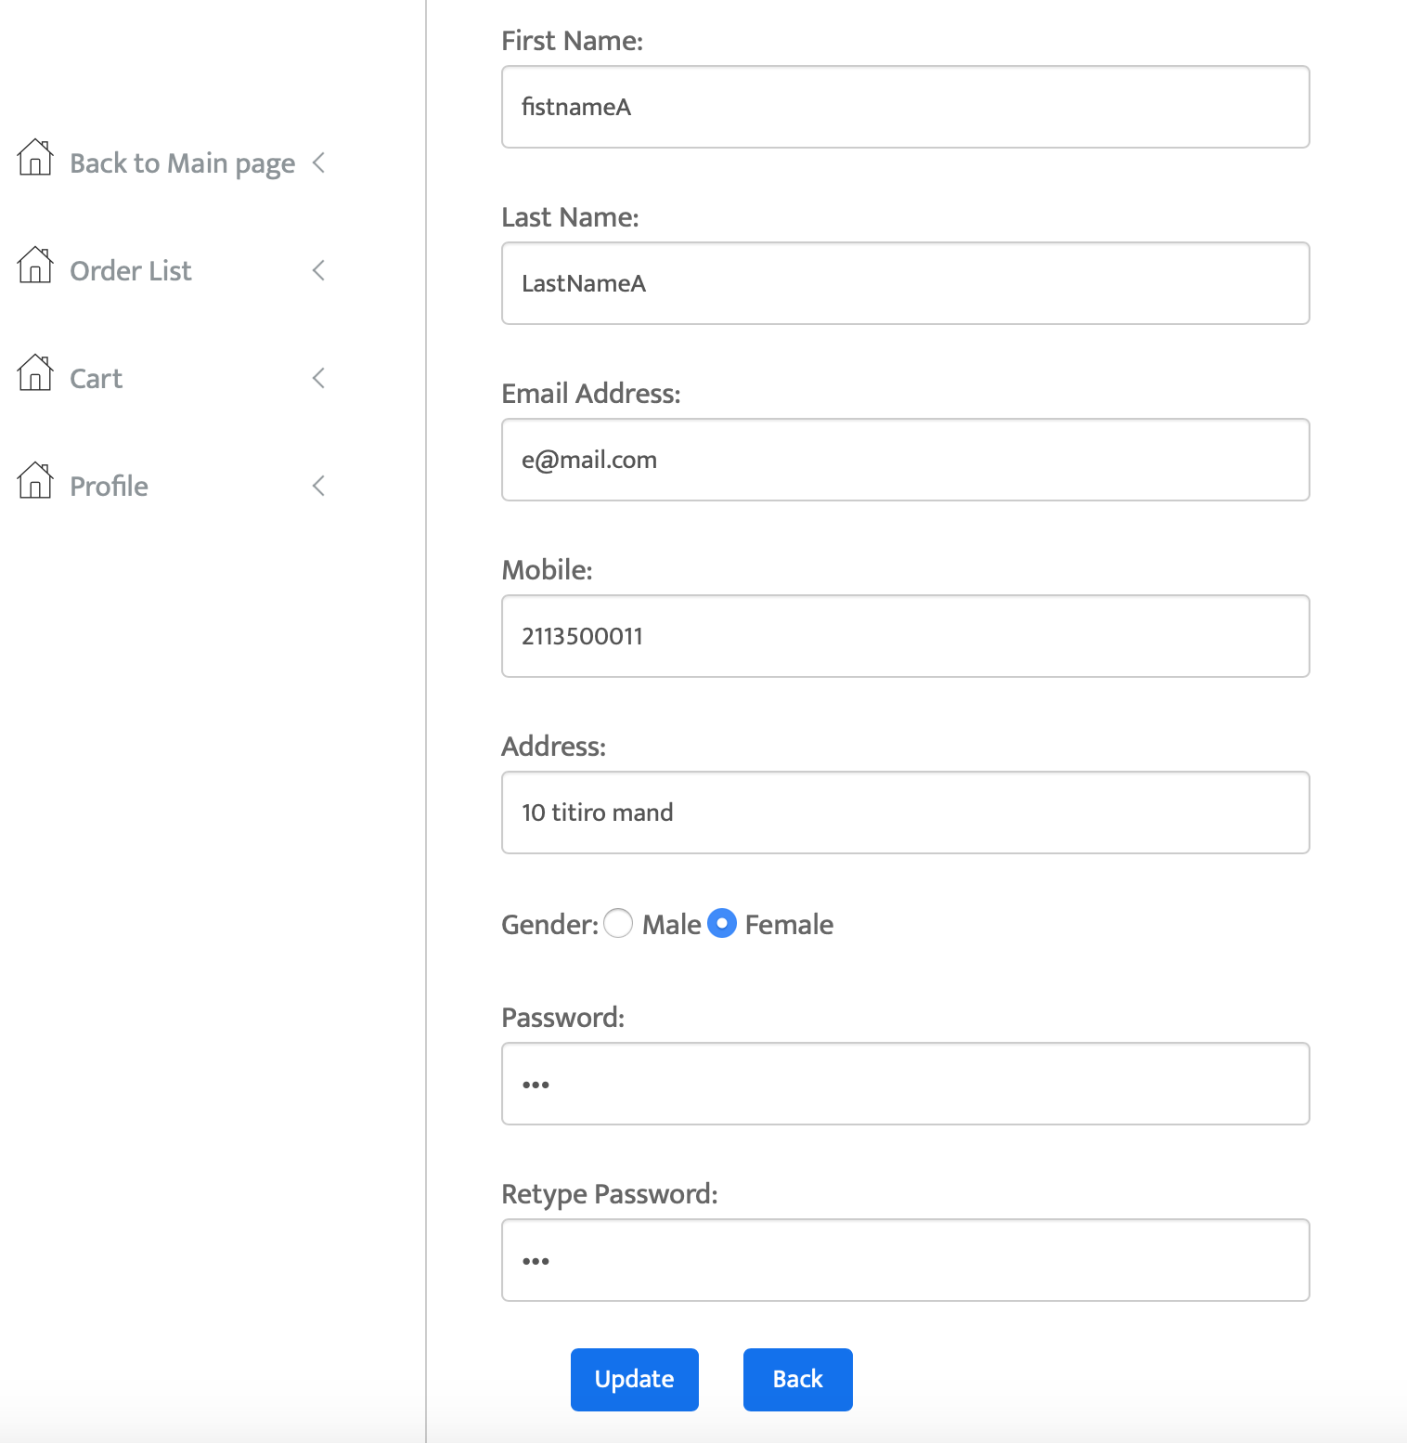

2.8.4 Operation instruction

To click the area of username, user can enter into the page of personal information. And then clicking profile button. User can see his/her personal information and change information here as above.

## Auction

2.9.1 Description

The function of auction supports users to bid goods and view the bid history.

2.9.2 Role

Administrator, User.

2.9.3 Function screenshots

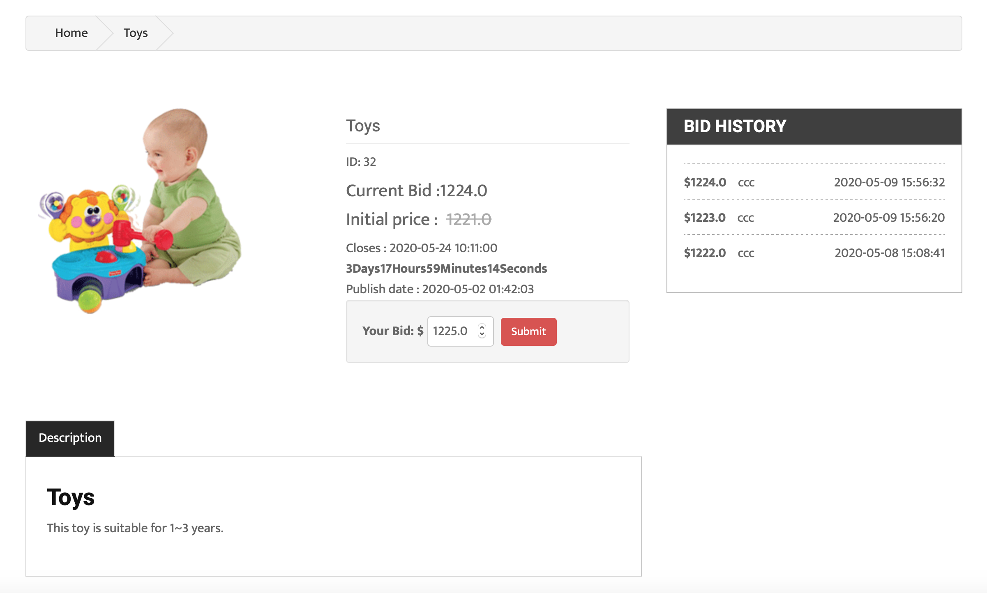

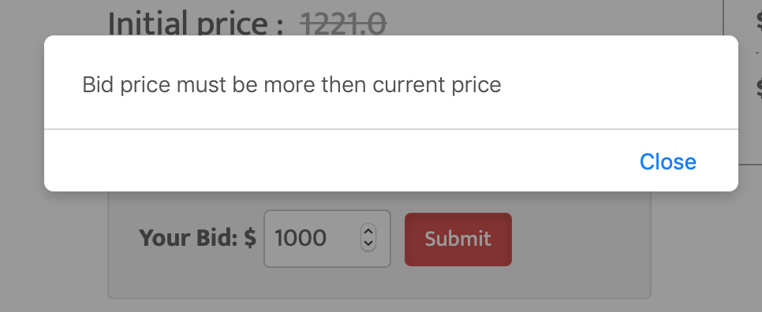

2.9.4 Operation instruction

If a user likes a product, he/she can click the product and enter into the bid page. There are the description of this product, initial price, closes time, publish date, remaining time and bid history. User can bid for his/her favourite product and see the bid history. If the price that user offered is less than the current price, the error message will be prompted as above.

## Make Appointments

2.10.1 Description

The function is to support user to make an appointment and pick up the goods in the store. The transaction will be closed.

2.10.2 Role

Administrator, User.

2.10.3 Function screenshots

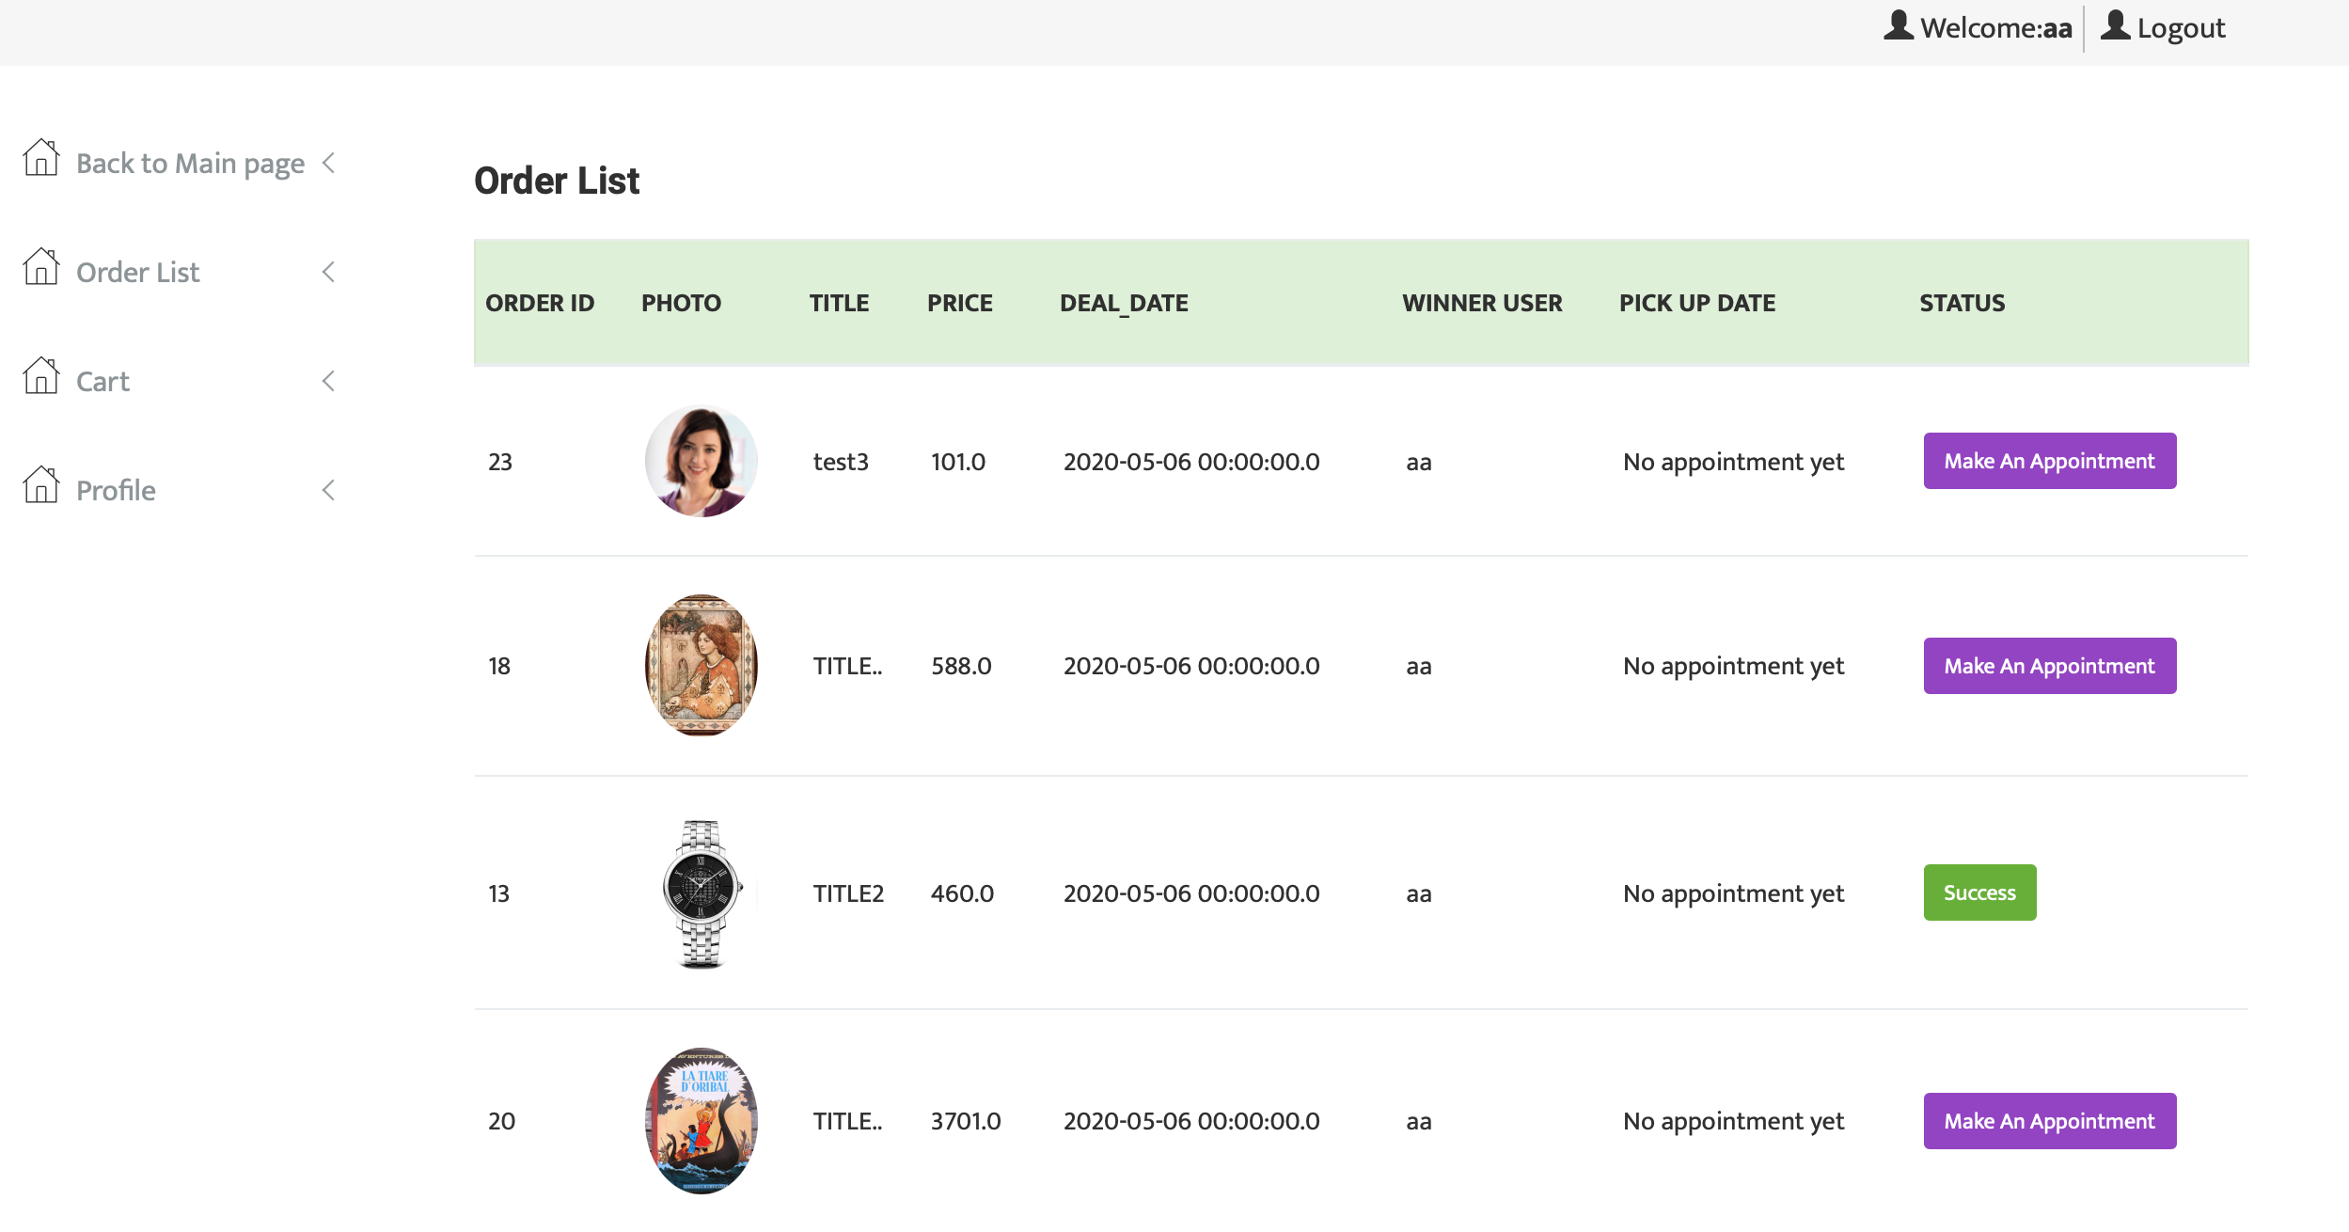

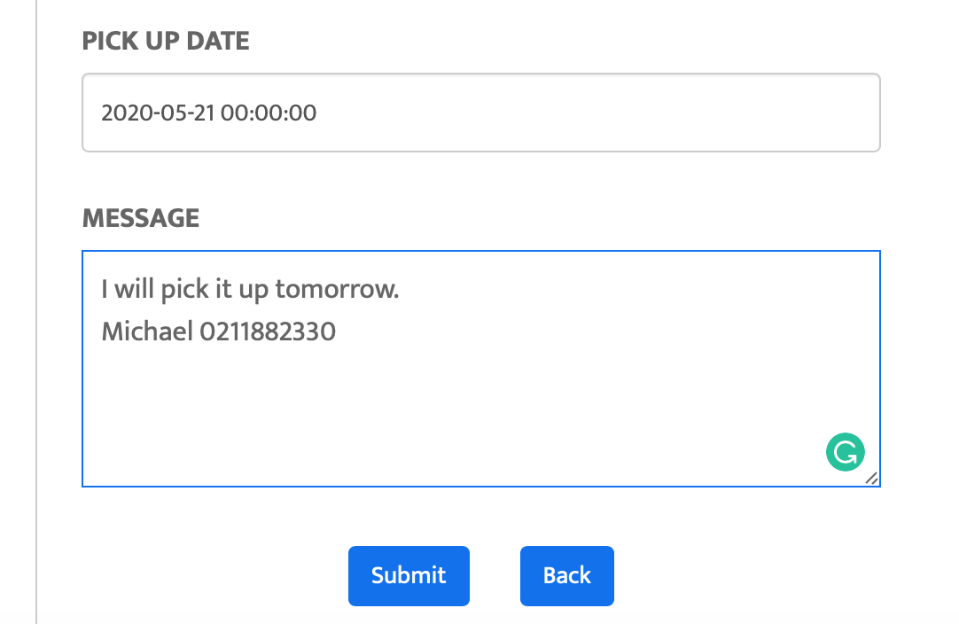

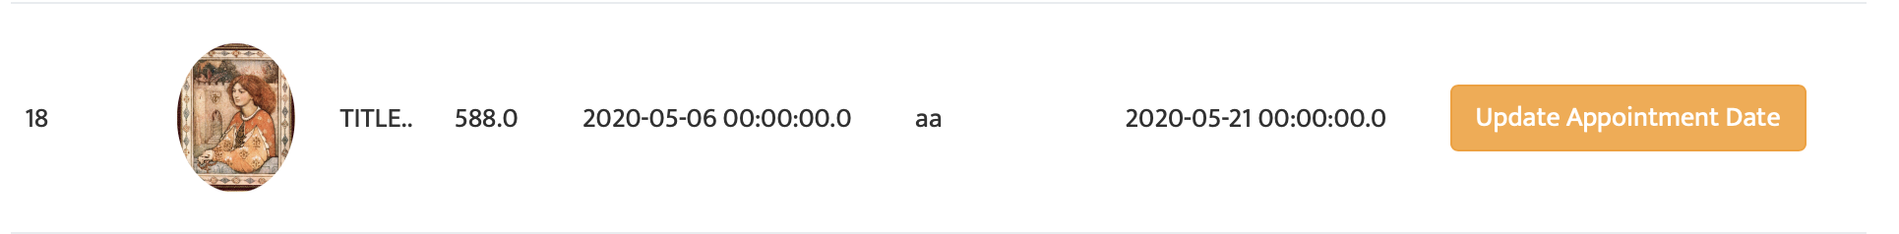

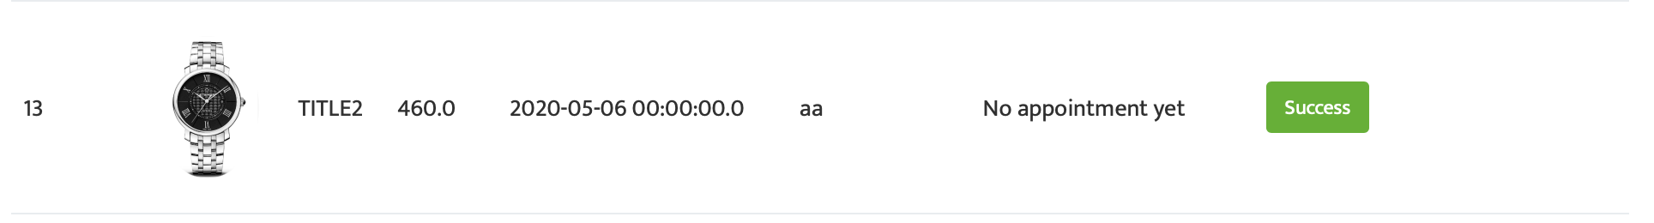

2.10.4 Operation instruction

If a user wins a bid, the user can enter into the page of order list. Here, User can see his/her successful bid. And then, user can click the button of making an appointment and input the time and notes. The appointment will be received by the administrator. Users can also update the information. If a user finish the pickup, the status will become success as above.

## Goods Management

2.11.1 Description

The function is to support administrator to manage goods, including uploading, modification and deleting.

2.11.2 Role

Administrator

2.11.3 Function screenshots

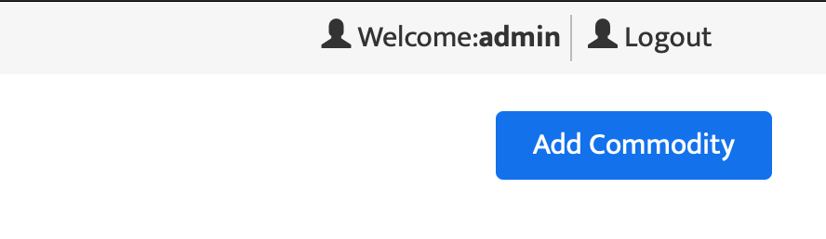

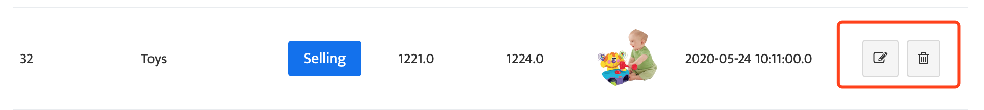

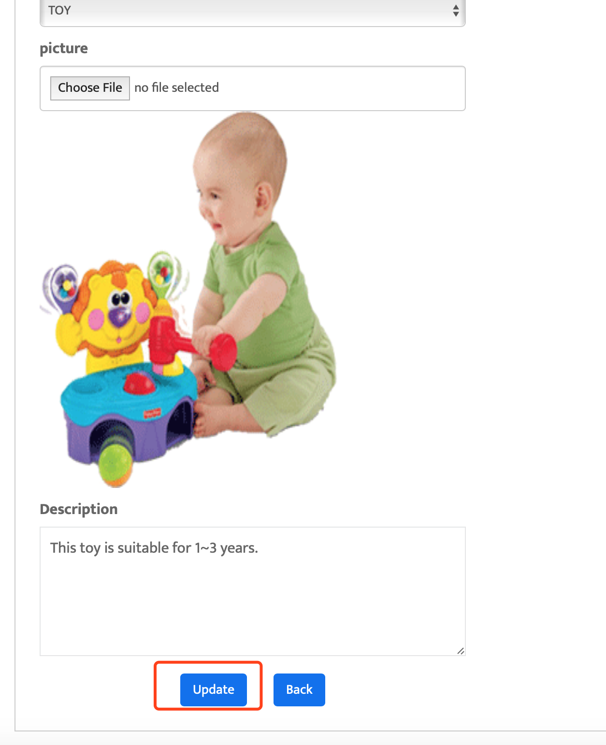

2.11.4 Operation instruction

To click the area of username, administrator can enter into the page of goods management. By clicking add button, administrator can upload products. And then, administrators can also modify or delete products on this page.

## Shopping Cart

2.12.1 Description

The function is to support users to add favourite goods into the cart.

2.12.2 Role

Administrator, User.

2.12.3 Function screenshots

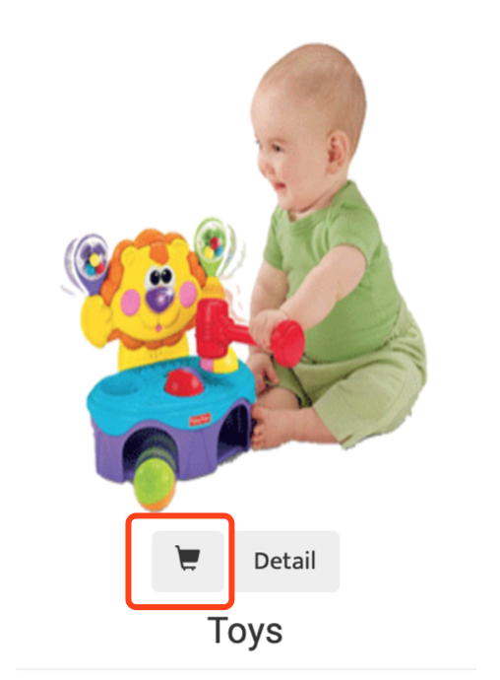

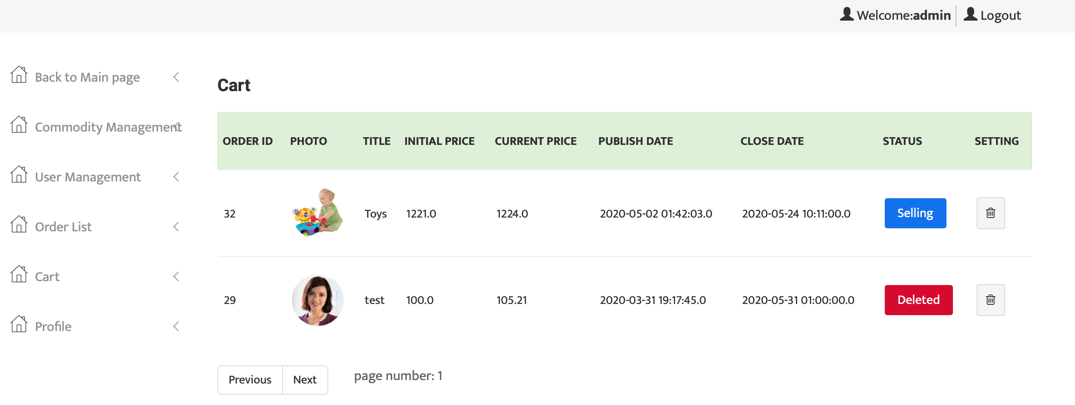

2.12.4 Operation instruction

To click the cart icon of a product, users can add the product into the shopping cart.

And, by clicking the cart button, users can see his/her products that he/she added before. User can see the status of a product, or delete the product on the page of shopping cart.

## User Management

2.13.1 Description

The function is to support administrator to manage users, including changing user’s status, changing administrator’s status and viewing user list.

2.13.2 Role

Administrator.

2.13.3 Function screenshots

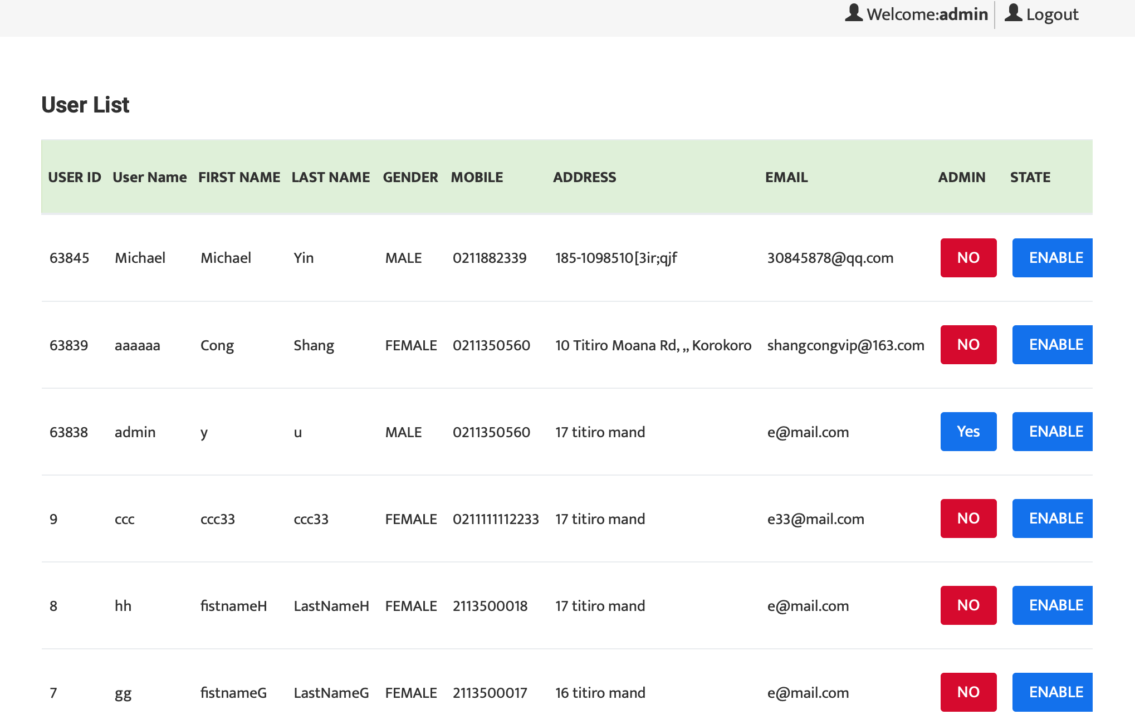

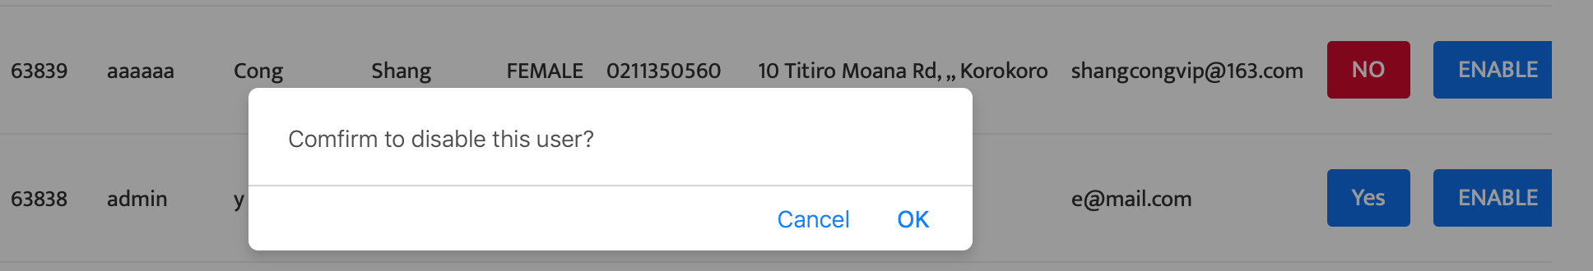

2.13.4 Operation instruction

To click the button of user management, administrator can enter into the page of user management. Administrators can see user’s information here, and change user’s status, such as enable or disable a user. Administrators can also change a user to administrator or change an administrator to a user.

## Order Management

2.14.1 Description

The function is to support administrator to manage order, including setting order’s status and viewing order list.

2.14.2 Role

Administrator.

2.14.3 Function screenshots

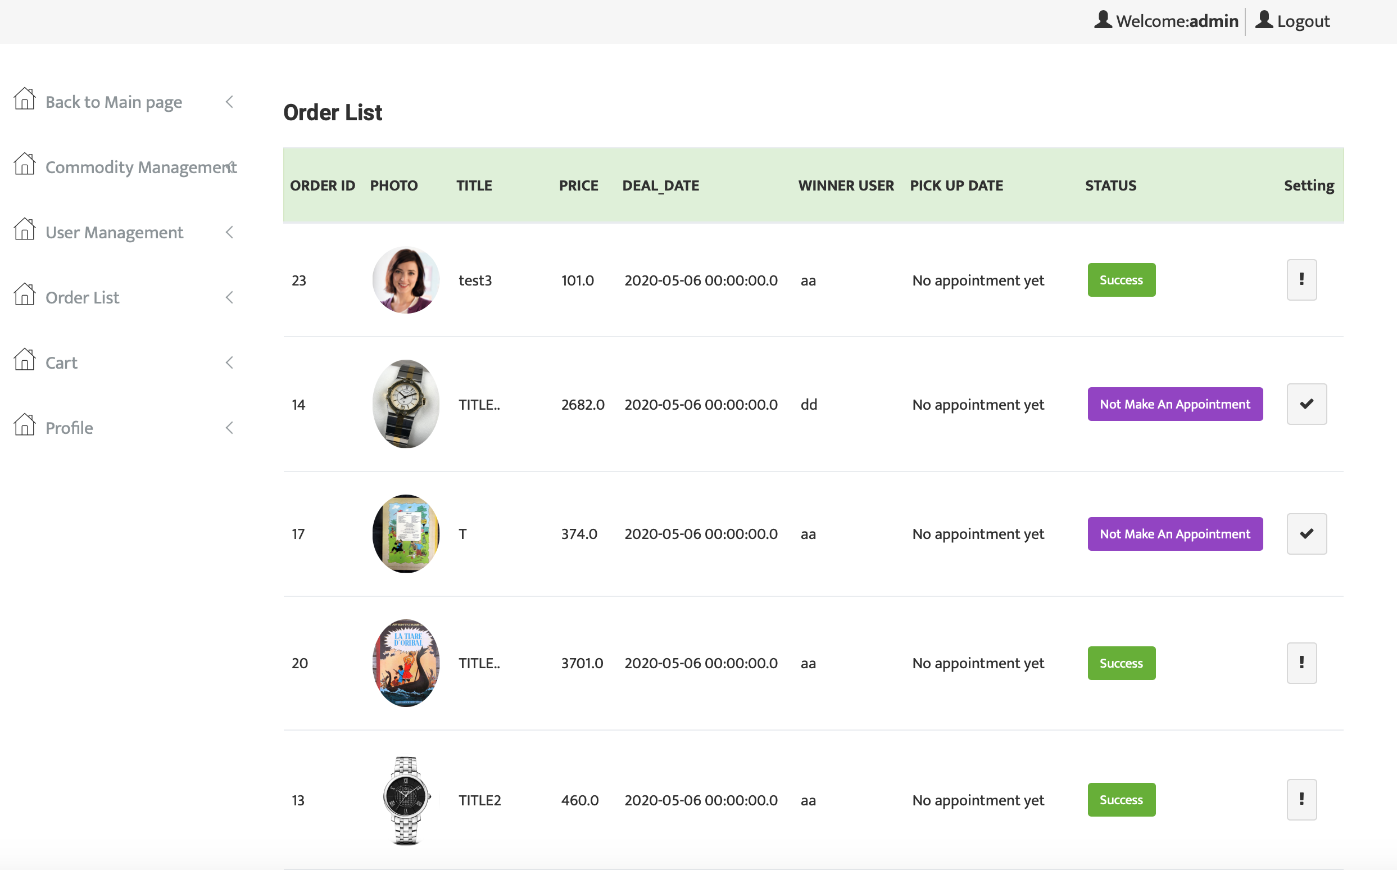

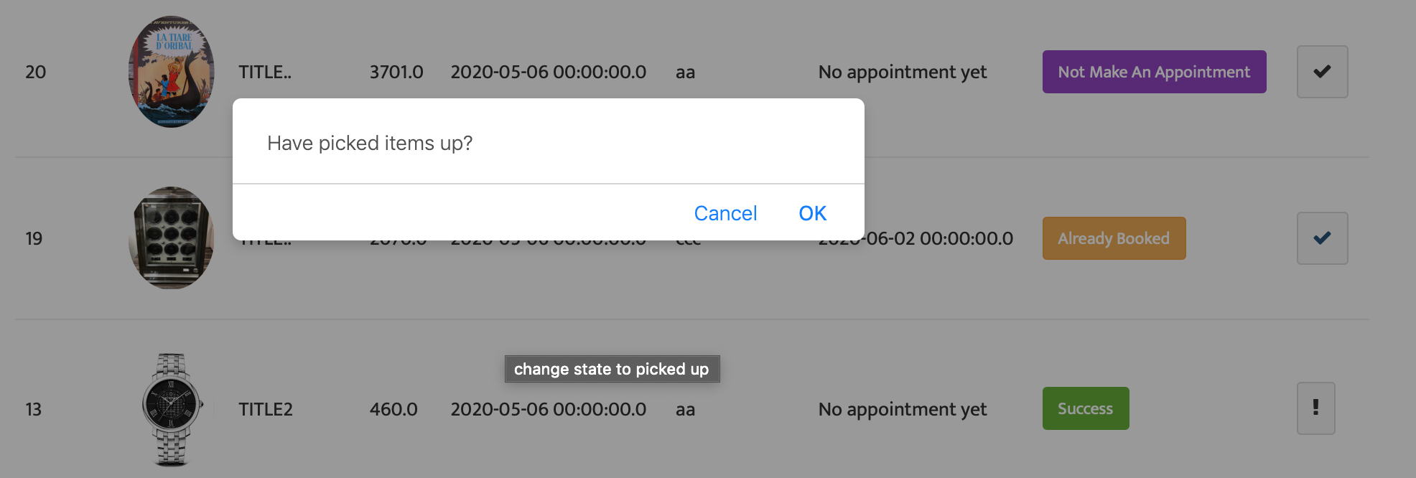



2.14.4 Operation instruction

To click the button of order list, administrators can enter into the page of order management. Administrators can see all orders which are bid by users here. There are three order status. If a user did not make an appointment, the status is not make an appointment. If a user made an appointment, the status is already booked. If a user has picked it up, the status is success.